Creating the environment-
PS C:\Users\Akanksha\Documents\IAAC\CLASSES\AI Labs\Group3-day1assignment> git remote -v
origin https://github.com/iaac-maai/Group3-day1assignment.git (fetch)
origin https://github.com/iaac-maai/Group3-day1assignment.git (push)
PS C:\Users\Akanksha\Documents\IAAC\CLASSES\AI Labs\Group3-day1assignment> python -m venv .venv
PS C:\Users\Akanksha\Documents\IAAC\CLASSES\AI Labs\Group3-day1assignment> .venv\Scripts\Activate.ps1
.venv\Scripts\Activate.ps1 : File C:\Users\Akanksha\Documents\IAAC\CLASSES\AI Labs\Group3-day1assignment\.venv\Scripts\Activate.ps1
cannot be loaded because running scripts is disabled on this system. For more information, see about_Execution_Policies at
https:/go.microsoft.com/fwlink/?LinkID=135170.
At line:1 char:1
+ .venv\Scripts\Activate.ps1
+ ~~~~~~~~~~~~~~~~~~~~~~~~~~
+ CategoryInfo : SecurityError: (:) [], PSSecurityException
+ FullyQualifiedErrorId : UnauthorizedAccess
PS C:\Users\Akanksha\Documents\IAAC\CLASSES\AI Labs\Group3-day1assignment> Set-ExecutionPolicy -Scope CurrentUser -ExecutionPolicy RemoteSigned
PS C:\Users\Akanksha\Documents\IAAC\CLASSES\AI Labs\Group3-day1assignment> .venv\Scripts\Activate.ps1
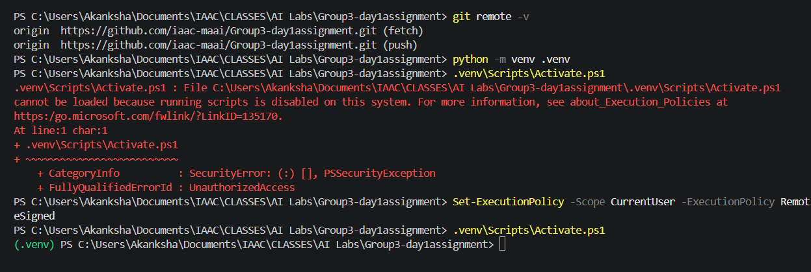
(.venv) PS C:\Users\Akanksha\Documents\IAAC\CLASSES\AI Labs\Group3-day1assignment>

pip install pandas numpy matplotlib seaborn jupyter kagglehub
Environment is ready
Working with on the repository together-
Git pull

